**Mini Project 3**

Compare Mongo DB versus my SQL

Zhou Fang

Mongo dB and MySQL are both database software for managing data. In the era of big data, people often need to store thousands or even hundreds of millions of data. Generally speaking, these data are not isolated, but have some connections. At this time, it is necessary to build a logical and fast management platform with database software.

* User Story of Store the Data

1. Network Bulletin Boards: As a network bulletin board, it needs to store the information of each user, such as usernames, passwords, and profiles. What’s more, it also needs to preserve blog posts, forum posts, and personal messages. Database software is able to store it and provide an efficient way of fetch data and display on the screen.
2. Student Project: As a student, sometimes we need to store a lot of project data. Those data is low value but large, possibly up to few gigabytes, and MongoDB is a good fit, as performs better than MySQL on massive data sets.
3. Finance Company: As an employee of a financial company, I need to store a lot of information about customers. This information may be related to the flow of tens of millions of dollars, so I need a database with a higher safety factor. At this time, I can use MySQL because its security factor is better than MongoDB.

* User Story of Display the Data

1. Network Bulletin Boards: After storing various data of the website, whenever a user request for them, the data base should find the right data as soon as possible and send it back to display on user’s web page. Therefore, a structured data storage mechanism like MySQL and MongoDB is important.
2. Embedded System: In the embedded environment, sometimes it cannot provide a lot of hardware resources support for the software system. At this time, if you need to store and read data normally and display it normally, you can use MySQL because it can run normally in a resource poor environment. MongoDB requires more hardware resources and is not suitable for some embedded environments.
3. Game Development: In the game industry, it often involves the reading of game resource files, with less changes and more content. In this case, MongoDB can be used, because it has better performance in reading and displaying, and JSON format files are widely used in the game industry, which can meet almost all the development needs.

* Unit Test
* MySQL

1. Install:

My version of MySQL is 8.0.18. While installing, I choose develop default version and Standalone/Classic so that I won’t miss any part of its basic and original experience.

For the server configuration type, as I only need a small test, I choose the Development Computer mode.

Before using it, it is strong recommended to set up a strong root password.

MySQL users are created in this step.

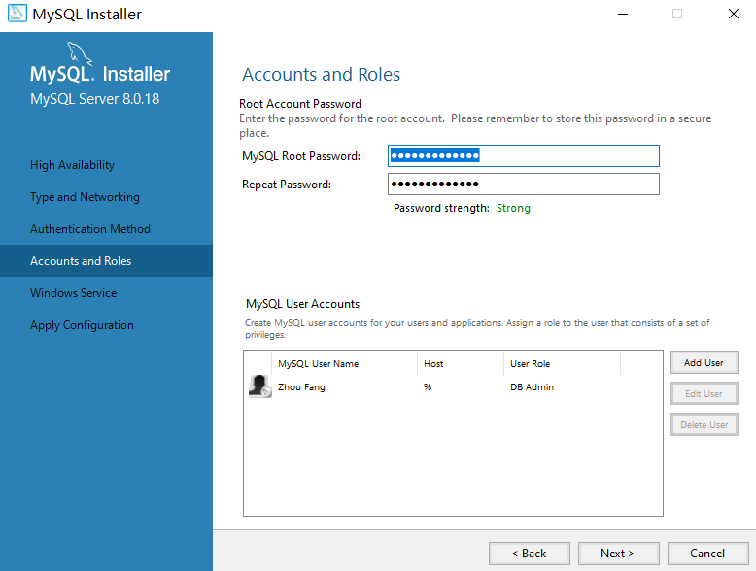

If all steps are correct, the CMD should look like this after entering SQL:

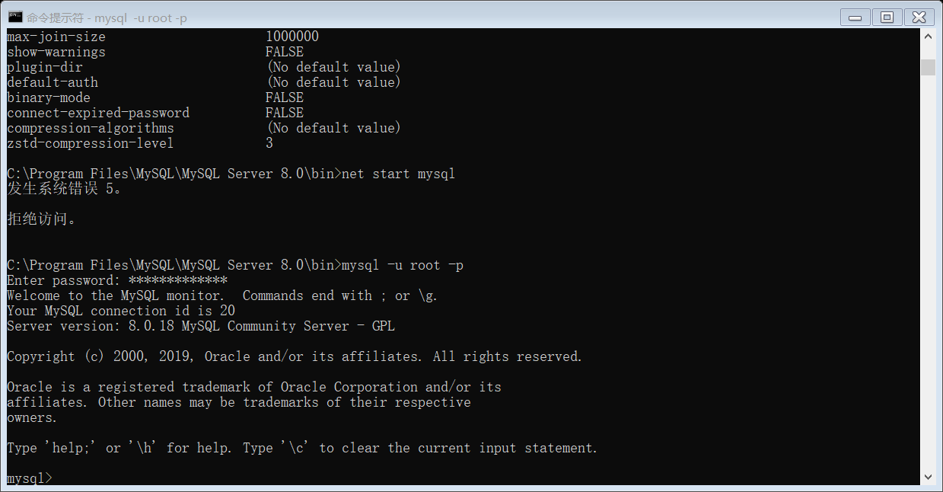

1. Create a new database: BU601_test_module.

The data type MySQL supported can be roughly divided into three types: numerical value, date and string.

1. Build a simple table: test



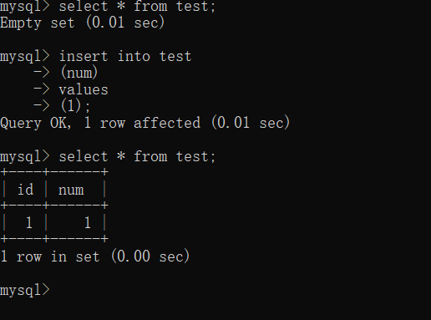

This table only stores integers and its sequence will increate automatically.

Use alter command can create new column for current table.

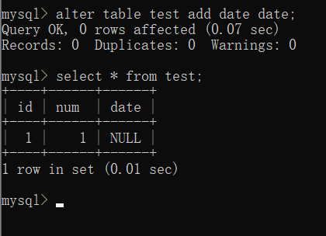

Now we can insert more data.

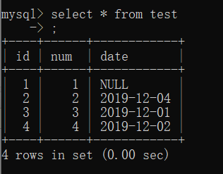

Where and Like commands are used to search specific data in table.

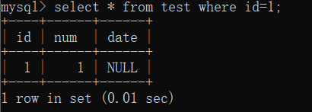

Order command is used to sort data. ASC stands for ascending order. If descending order is needed, use DESC.

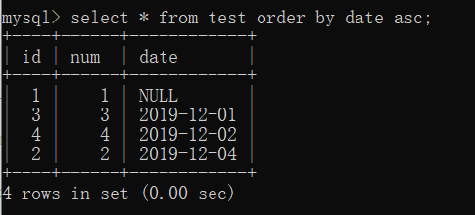

* Mongo DB

After installation, new data and log folders need to be set up by my own. Then, in cmd type in commands as below will make it possible to launch MongoDB by only type *Net Start MongoDB:*

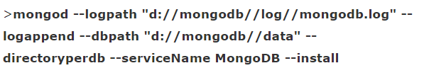

Note that this requires running the CMD as an administrator first.

1. Create Data Base:

*USE* command in MongoDB could be used to switch to a specified data base. If the data base is not exist, then a new one will be create, which is extremely convenient.

1. Basic Operation of Document:

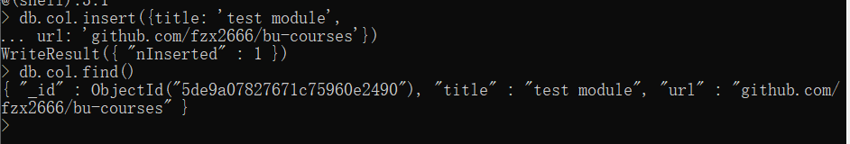

Also, inserted documents could be updated, using update() command.





Like MySQL, MongoDB also provided a better visualized form to display current documents by using pretty() command.

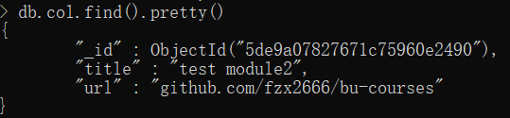

Before the next step, I delete this test module document.

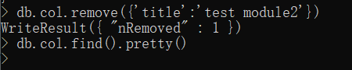

1. Relationship

There are four kinds of relationship in Mongo DB: 1:1, 1:N, N:1, N:N.

First of all, in order to test the 1:N relationship, I insert new documents to the collection.

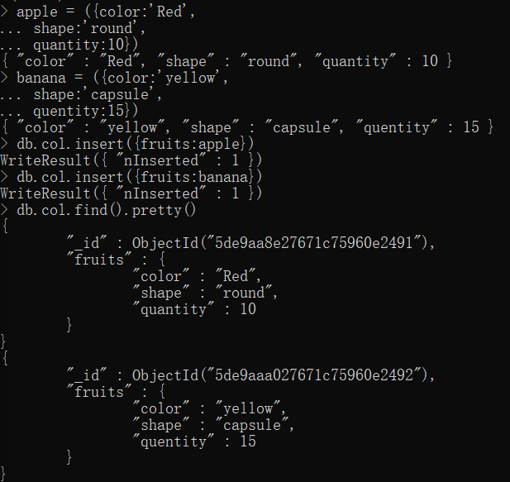

All fruits have multiple attributes.

* Overall Comparison

Both MySQL and Mongo DB can deal with mountainous of data and they are both open-source. But their have different functions and characters.

1. Mongo DB are optimized for web application. MySQL is utility and Mongo DB is more like a system specially optimized for a networked distributed system.
2. MongoDB is younger and easier to install. During installation, MySQL requires several manual operation, while MongoDB nearly need nothing. However, youth means unstable and imperfect mechanism.
3. Data sets are named table in MySQL and collection in MongoDB.
4. MongoDB store data in a document form which is similar to json. Therefore, MongoDB is easier to operate and more efficient in some ways. For Example, if billions of data needed to be store in a data base, MongoDB will probably run much faster than MySQL. What’s more, this form make it possible form MongoDB to utilize embedded documents.
5. MongoDB is NoSQL, which means it only has weak support of transaction.